**Introduction to Razor Pages with Entity Framework : Workshop-3**

Welcome to the dynamic world of web development using Razor Pages and Entity Framework (EF). Razor Pages is a lightweight web framework in ASP.NET Core that enables you to build web applications with simplicity and flexibility.

**Razor Pages:**

- Emphasizes code simplicity.

- Utilizes a page-focused approach for building UI.

- Integrates seamlessly with ASP.NET Core.

**Entity Framework:**

- A powerful Object-Relational Mapping (ORM) framework.

- Simplifies database interactions in your application.

- Provides a convenient way to work with databases using C#.

**Why Combine Razor Pages with EF:**

- Rapid development with minimal boilerplate code.

- Seamless integration for building data-driven applications.

- Simplified syntax and structure for managing UI and data logic.

This powerful combination empowers developers to create efficient and scalable web applications with ease. Whether you are a beginner or an experienced developer, Razor Pages with EF offers a straightforward approach to building modern web solutions. Dive in and explore the endless possibilities of web development!

**Dear students,** for your hands-on learning experience with Razor Pages and Entity Framework, please create the following models with their respective primary and foreign key relationships:

**1. Applications:**

*Columns:*

- Id (uniqueidentifier) [Primary Key]

- UserId (uniqueidentifier) [Foreign Key: Users(Id)]

- JobId (uniqueidentifier) [Foreign Key: Jobs(Id)]

- CompanyId (uniqueidentifier) [Foreign Key: Companies(Id)]

- AppliedDate (date)

- Status (varchar(50))

**2. Companies:**

*Columns:*

- Id (uniqueidentifier) [Primary Key]

- Name (varchar(100))

- Email (varchar(50)) [Unique Constraint]

- Website (varchar(50))

- Phone (varchar(50))

- Logo (varchar(50))

- About (varchar(100))

- Vision (varchar(100))

- Mission (varchar(100))

- Location (varchar(50))

- Address (varchar(50))

- Status (varchar(50))

- CreatedDate (date)

**3. Interviews:**

*Columns:*

- Id (uniqueidentifier) [Primary Key]

- CompanyId (uniqueidentifier) [Foreign Key: Companies(Id)]

- JobId (uniqueidentifier) [Foreign Key: Jobs(Id)]

- JobseekerId (uniqueidentifier) [Foreign Key: Users(Id)]

- Date (date)

- Time (time(7))

- Location (varchar(50))

- Status (varchar(50))

- CreatedBy (uniqueidentifier) [Foreign Key: Users(Id)]

- CreatedDate (date)

*Constraints:*

- Foreign Key: CompanyId references Companies(Id)

- Foreign Key: JobId references Jobs(Id)

- Foreign Key: JobseekerId references Users(Id)

- Foreign Key: CreatedBy references Users(Id)

**4. Jobs:**

*Columns:*

- Id (uniqueidentifier) [Primary Key]

- Title (varchar(50))

- Description (varchar(50))

- Location (varchar(50))

- Experience (varchar(50))

- TypeOfWorkPlace (varchar(50))

- Salary (varchar(50))

- Responsibilities (varchar(50))

- JobType (varchar(50))

- VacanciesCount (int)

- AppliedCount (int)

- Status (varchar(50))

- CompanyId (uniqueidentifier) [Foreign Key: Companies(Id)]

- CreatedDate (date)

- CreatedBy (uniqueidentifier) [Foreign Key: Users(Id)]

*Constraints:*

- Foreign Key: CompanyId references Companies(Id)

- Foreign Key: CreatedBy references Users(Id)

**5. Qualifications:**

*Columns:*

- Id (uniqueidentifier) [Primary Key]

- UserId (uniqueidentifier) [Foreign Key: Users(Id)]

- Title (varchar(50))

- Mark (varchar(50))

- YearOfPassout (varchar(50))

- University (varchar(50))

- Status (varchar(50))

*Constraints:*

- Foreign Key: UserId references Users(Id)

**6. Skills:**

*Columns:*

- Id (uniqueidentifier) [Primary Key]

- UserId (uniqueidentifier) [Foreign Key: Users(Id)]

- Title (varchar(50))

- Status (varchar(50))

*Constraints:*

- Foreign Key: UserId references Users(Id)

**7. Users:**

*Columns:*

- Id (uniqueidentifier) [Primary Key]

- FirstName (varchar(50))

- LastName (varchar(50))

- Email (varchar(50)) [Unique Constraint]

- Gender (varchar(50))

- Location (varchar(50))

- Phone (varchar(50))

- Password (varchar(50))

- Role (varchar(50))

- About (varchar(50))

- Designation (varchar(50))

- CompanyId (uniqueidentifier) [Foreign Key: Companies(Id)]

- Status (varchar(50))

- Image (varchar(50))

- CreatedDate (date)

*Constraints:*

- Foreign Key: CompanyId references Companies(Id)

Feel free to dive in and create these models to strengthen your understanding of building database structures for web applications.

**Task: Build a Post Job Screen**

Create a screen for employers to post job openings using Razor Pages and Entity Framework. Follow these steps:

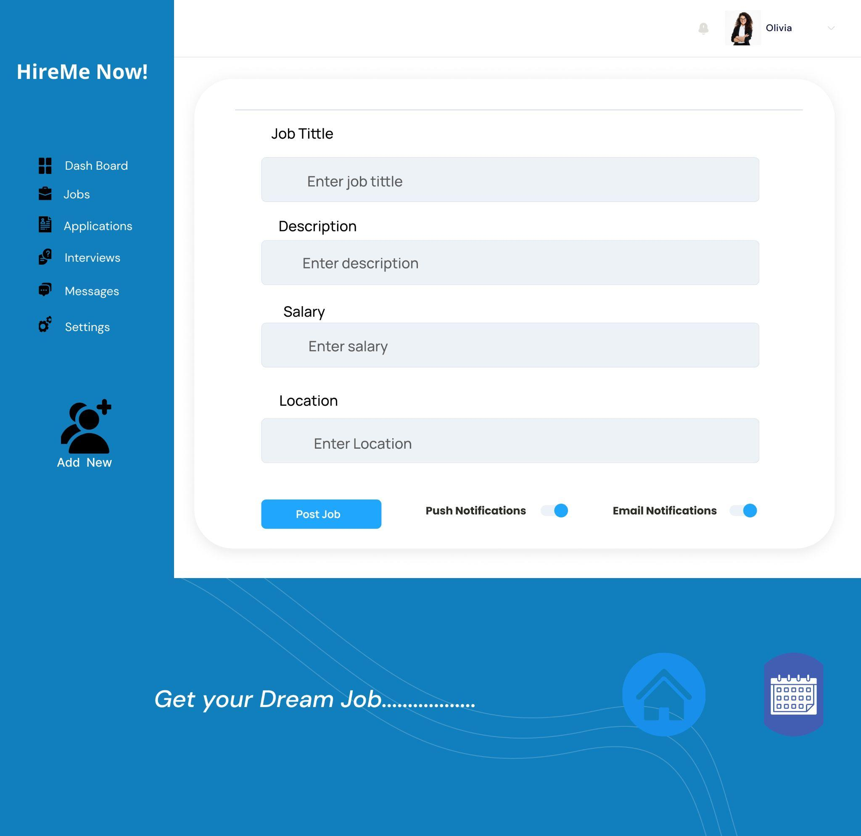

1. Design a form:

- Fields for job details.

2. Backend logic:

- Handle submissions, store data.

3. Validation:

- Ensure proper input validation.

4. Verify submission:

- Check the database for accurate storage.

5. User feedback:

- Provide clear success/failure messages.

This task assesses your ability to handle form submissions and database interactions.

**Happy coding! 😊**